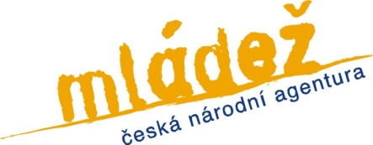

Youth Exchange
Intercultural Communication through Culinary Arts
(9th-15th September 2013, Oucmanice, Czech Republic)

APPLICATION FORM

Name |  |  | Surname
Country |  |  | Gender
Full address
Email |  |  | Phone number
Knowledge  of English | Fluent  □ | Good  □ |  | Basic  □

Passport details
Passport number
Date of birth |  | Place of birth
Date of issue |  | Place of issue
Date of expiry

Travel details
Estimated travel costs
Travel from (city) |  | Travel by (mean of transport)

Practical information
Vegetarian | Yes    | No    | Special needs

Please describe your previous experience with the topics of the youth exchange- sustainable food practices; nutrition; interculturality
Please describe the level of your culinary skills

What is your motivation to take part in this youth exchange?

What are your expectations of this youth exchange?

Please return this form to
Ramona Costin ramo_chi@yahoo.com
Deadline: 24th August 2013

